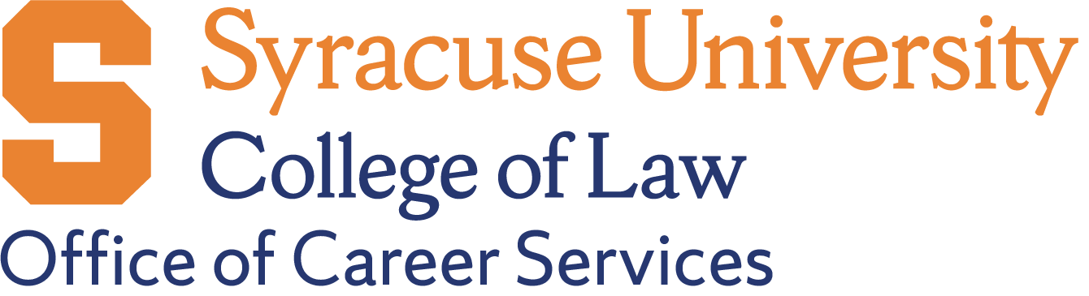

Virtual & Asynchronous Pro Bono Opportunities for Law Students

ABA Free Legal Answers
- Website: https://www.abafreelegalanswers.org
- What it is: Online platform where you answer civil legal questions from low-income individuals
- Time commitment: Flexible - answer questions as your schedule allows
- Requirements: Must be supervised by a licensed attorney; some states allow law students to participate under attorney supervision
- Note: Check if your state participates and allows student volunteers

Immigration Advocates Network (Pro Bono Connector)
- Website: https://www.immigrationadvocates.org/nonprofit/legaldirectory
- What it is: Connects volunteers with immigration legal service providers nationwide
- Time commitment: Varies by project
- Work type: Document preparation, intake interviews, legal research, Know Your Rights presentations (many now virtual)

Lawyers for Good Government (L4GG)
- Website: https://www.lawyersforgoodgovernment.org/pro-bono-programs
- What it is: Rapid response network for civil rights and immigration issues
- Time commitment: Project-based
- Work type: Legal research, document review, client communications (often remote)

Volunteer Lawyers Network (VLN) - Minnesota
- Website: https://www.vlnmn.org
- What it is: Virtual clinic opportunities and remote legal services
- Time commitment: Flexible
- Work type: Virtual clinics, phone consultations, document prep
- Note: Good model - check if your local legal aid has similar programs

Legal Services Corporation (LSC) Grantees
- Website: https://www.lsc.gov/what-legal-aid/find-legal-aid
- What it is: Many LSC-funded organizations nationwide now offer remote volunteer opportunities
- Recommendation: Search for your region and ask about virtual projects

New York State Courts Virtual Volunteer Programs
- Check with: NYS Unified Court System's Access to Justice Program
- Work type: Virtual help centers, document review

How to Find More Opportunities

General Resources:
- Pro Bono Net: https://www.probono.net
- ABA Center for Pro Bono: https://www.americanbar.org/groups/probono_public_service
- Your State Bar Association: Most have pro bono coordinators

Questions to Ask Organizations:
- Do you accept remote volunteers?
- Can law students participate under attorney supervision?
- What training do you provide?
- How do you verify hours for bar admission requirements?
- Can I complete work asynchronously or do you need specific availability?

